

ATAR Biology

Unit 2: Topic 4

Week 28: Vascular Plants - Transport

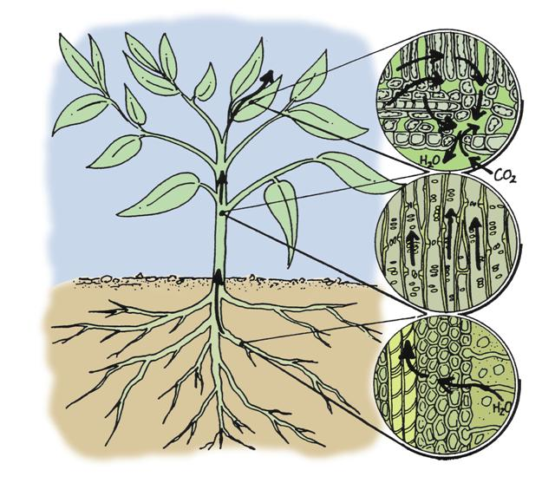
© SIDE

Student Study Notes

Unit Content
- Multicellular organisms have a hierarchical structural organisation of cells, tissues, organs and systems.
- In vascular plants, transport of water and mineral nutrients from the roots occurs via xylem through root pressure, capillary action (adhesion and cohesion of water molecules), transpiration; transport of the products of photosynthesis and some mineral nutrients occurs by translocation in the phloem.

Multicellular organisms

As mentioned in Topic 2, materials are able to move through the semipermeable membrane of a cell by the process of diffusion. In this section you will develop your understanding of how multicellular organisms acquire and transport materials within the internal environment.

Vascular plants
Most simple plants, such as moss, lack true roots and therefore must live in a moist environment where nutrients and water can be absorbed by diffusion.
Plants such as ferns, conifers and angiosperms have a transport system called the vascular system which extends throughout the roots, stem and leaves of the plant. The vascular tissue system is used to transport water and other materials.
The diagram below shows the structures involved in the movement of water from the roots to the rest of the plant and out through the leaves.

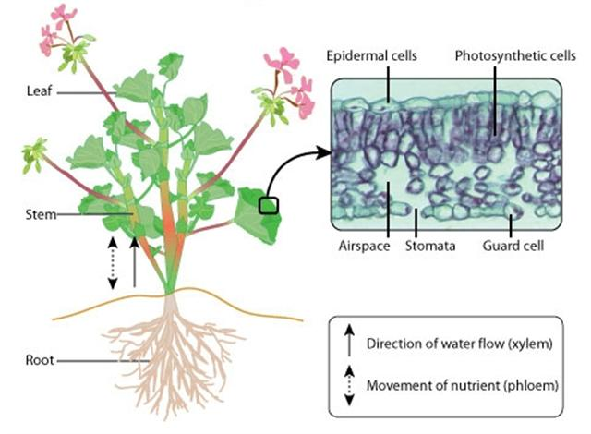
© WestOne
Translocation

Translocation, in plants, is the movement of sugars, minerals and other nutrients in solution through the phloem. This is the sap found in most plants.

The phloem consists of thin elongated living cells joined end to end. Each cell, known as a sieve tube, is separated by sieve plates through which phloem can pass.
Phloem cells lack organelles and form a continuous tube separated by sieve plates. Sieve plates contain pores to allow the thin cytoplasm to form a continuous stream for the passage of sugars from one cell to the next. Associated companion cells contain organelles that assist the phloem cell function.
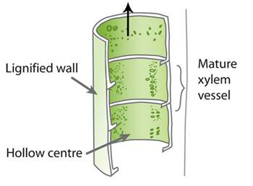
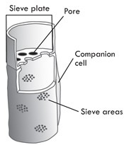

© WestOne

Xylem vessels
Xylem tissue transports the water needed for photosynthesis up the stem to the leaves. Xylem is a specialised tissue in plants consisting of long, hollow cells.

When xylem tissue dies, the ends of the cells break down to form thin tubes through which water can flow. This stream-like movement of water through the xylem is known as the transpiration stream.

Xylem is adapted for the transport of water for the following reasons:
- Xylem vessels (cells) are hollow and joined end-to-end, forming a continuous tube which allows a constant stream of water to move up the plant from the roots to the leaves.
- The cell wall of a single xylem vessel is strengthened and waterproofed by tissue called lignin.

Structure of Roots
Water is absorbed through the root system. Root hair cells form a barrier only one cell thick between the root and the soil. These specialised cells have a large surface area to volume (SA:V) ratio that enables them to collect water from the soil.

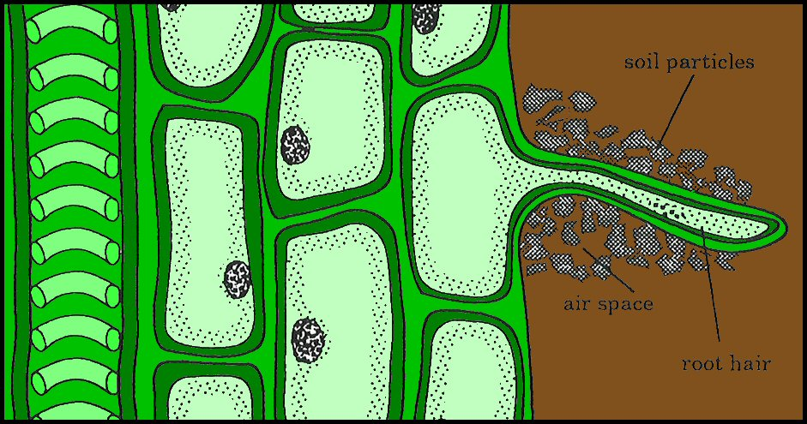

© SIDE

Mineral salts are actively transported into the root hairs. This creates a higher concentration of salts inside the root hair than in the soil. Water moves into the root hair by osmosis. The water then moves from cell to cell towards the centre of the root where it travels up the stem.

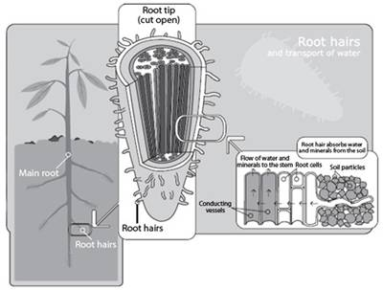

© WestOne

Water movement in xylem
Three processes ensure that water moves up the plant from the roots: root pressure, capillarity and transpiration.

Root pressure
The force of water being drawn in by osmosis in the root hair region forces the water up the xylem.

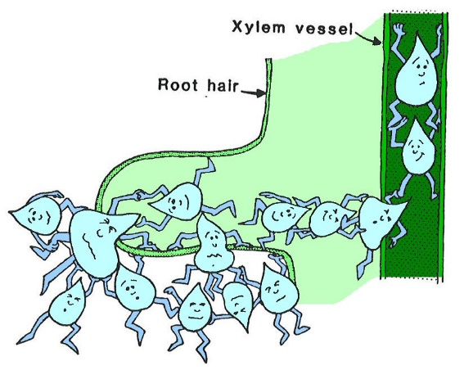

© SIDE

Capillary action
In water there are forces of attraction between the water molecules (cohesion) and forces of attraction between the water molecules and the xylem vessel wall (adhesion). Water will rise automatically in a narrow tube. Xylem vessels are narrow tubes and capillary action can account for movement of water a short distance up the stem.
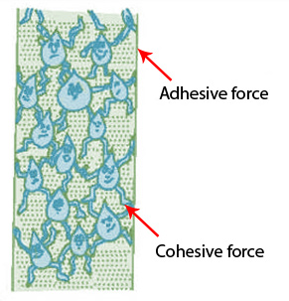
© SIDE

Transpiration
Root pressure and capillary action cannot account for the movement of water up tall trees. A third process, transpiration, is thought to be the main force involved in water transport. Water is drawn up the xylem from the roots to replace water vapour lost from the plant to the atmosphere by transpiration.
It appears then that water rises up the stem ‘pushed’ from below and ‘pulled’ from above.
PRACTICE QUESTIONS

1. The structural adaptations of xylem vessels are related to function. Complete the sentences using the words given below.
continuous water leaves roots hollow

a. Xylem cells are adapted to transport _____________

b. Xylem cells are ______________ tubes

c. Xylem cells join to form a _______________ tube

d. Xylem transports _______________ up from _________ to _________ .

2. What is the translocation and where does it occur in a plant?

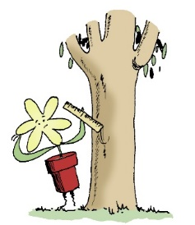
3. Ring barking is a method used to kill trees. A ring about 30 cm wide is cut around a tree and the bark and underlying phloem tissue are removed. From your knowledge of the plant vascular system, explain how ring barking would cause a tree to die.

© SIDE

4. Describe the cohesion-tension theory of water transport in the xylem.

5. Describe the processes involved in the transport of sugars in plant stems.

6. Complete the following table:

Tissue | Cell Type(s) | Role within the plant
Parenchyma | Parenchyma cells | Involved in respiration, photosynthesis, storage and secretion.
Collenchyma
Sclerenchyma
Root endodermis | Endodermal cells
Leaf mesophyll | Spongy mesophyll cells  Palisade mesophyll cells
Xylem
Phloem

Capillarity and water movement activity
Four capillary tubes of different width are set up as below.
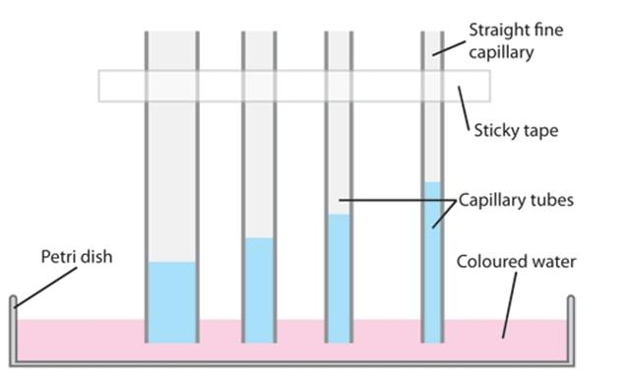
- What do you notice about the levels of coloured water in the tubes?

- What structures in a plant might correspond to these glass capillaries?

3. Although the xylem vessels are finer than any of the capillaries we have set up, measurements show that they are still not fine enough for water to rise in them to the height of a tall tree. However, the spaces between cellulose fibres in the leaf cell walls are very fine indeed. These can be thought of as tiny capillaries, and measurements show that they are quite fine enough to hold water at the height of a tall tree.
However, if the tree has fine capillaries at the end of the branches, and xylem vessels below them, the system is not quite the same as the tubes set up. In what ways is it different?

